David Mariani

650.483.4491

INSTRUCTIONS FOR adding a new parishioner to finalsite

Table of Contents

Add a new parishioner 3

Step 1: Login to Finalsite 3

Step 2: choose Constituents Manager from the drop down 4

Step 3: click on the add new constituents button 5

Step 4: fill in name section and household relationship 6

Step 5: fill in the parish info section and click update profile button 7

step 6: Click on the add a new address link, fill in the form, click Add address 8

step 7: click on the add a new relationship link & click browse button 9

Step 8: select parishioners group and select related profile 10

step 9: click on the add relationship button & repeat steps 7-9 if necessary 11

step 10: click on the groups tab, click on the more groups & click save mem.. 12

step 11: click on the roles tab & check the roles & click the save roles button 13

Step 12: click on the account tab and click on the create portal login button 14

step 13: fill in username and password and click the create login button 15

# Add a new parishioner

First launch your web browser and enter the following address: <http://angels.finalsite.com/admin.cfm>

## Step 1: Login to Finalsite

Login to Finalsite and choose **Constituents Manager** from the drop down

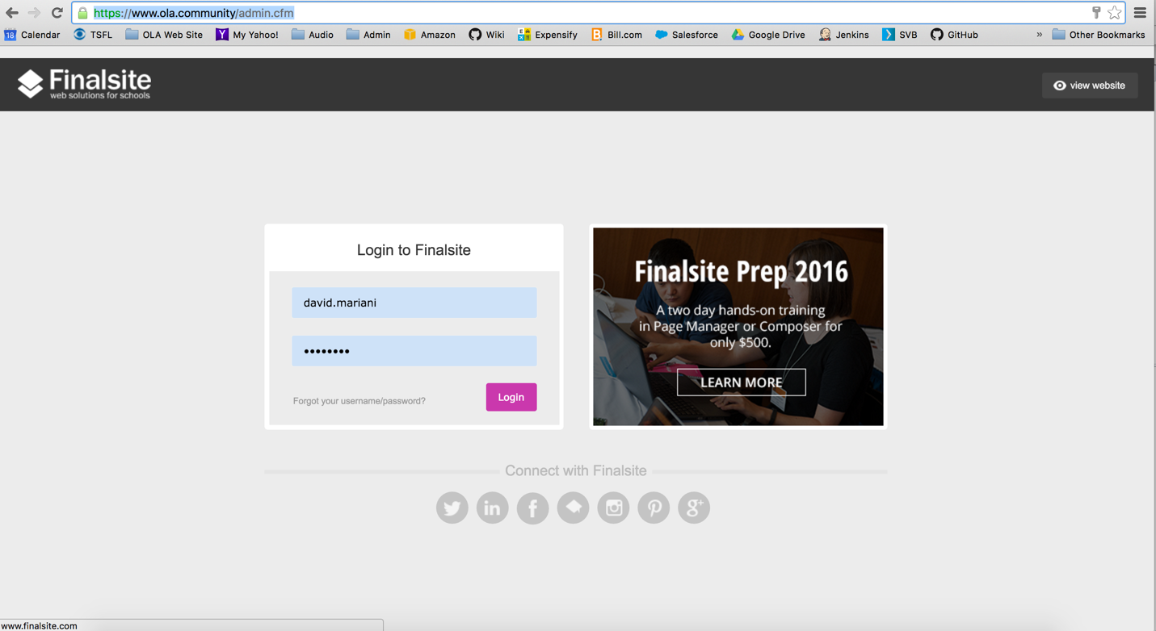

## Step 2: choose **Constituents Manager** from the drop down

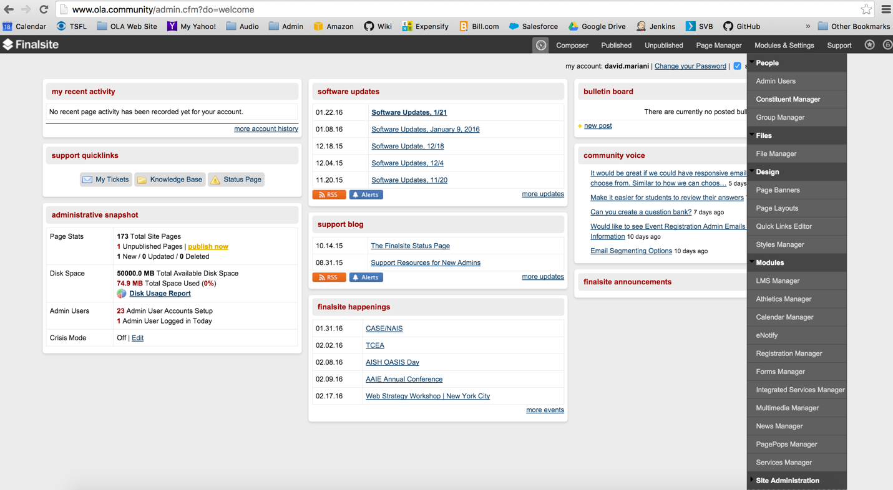

## Step 3: click on the **add new constituents** button

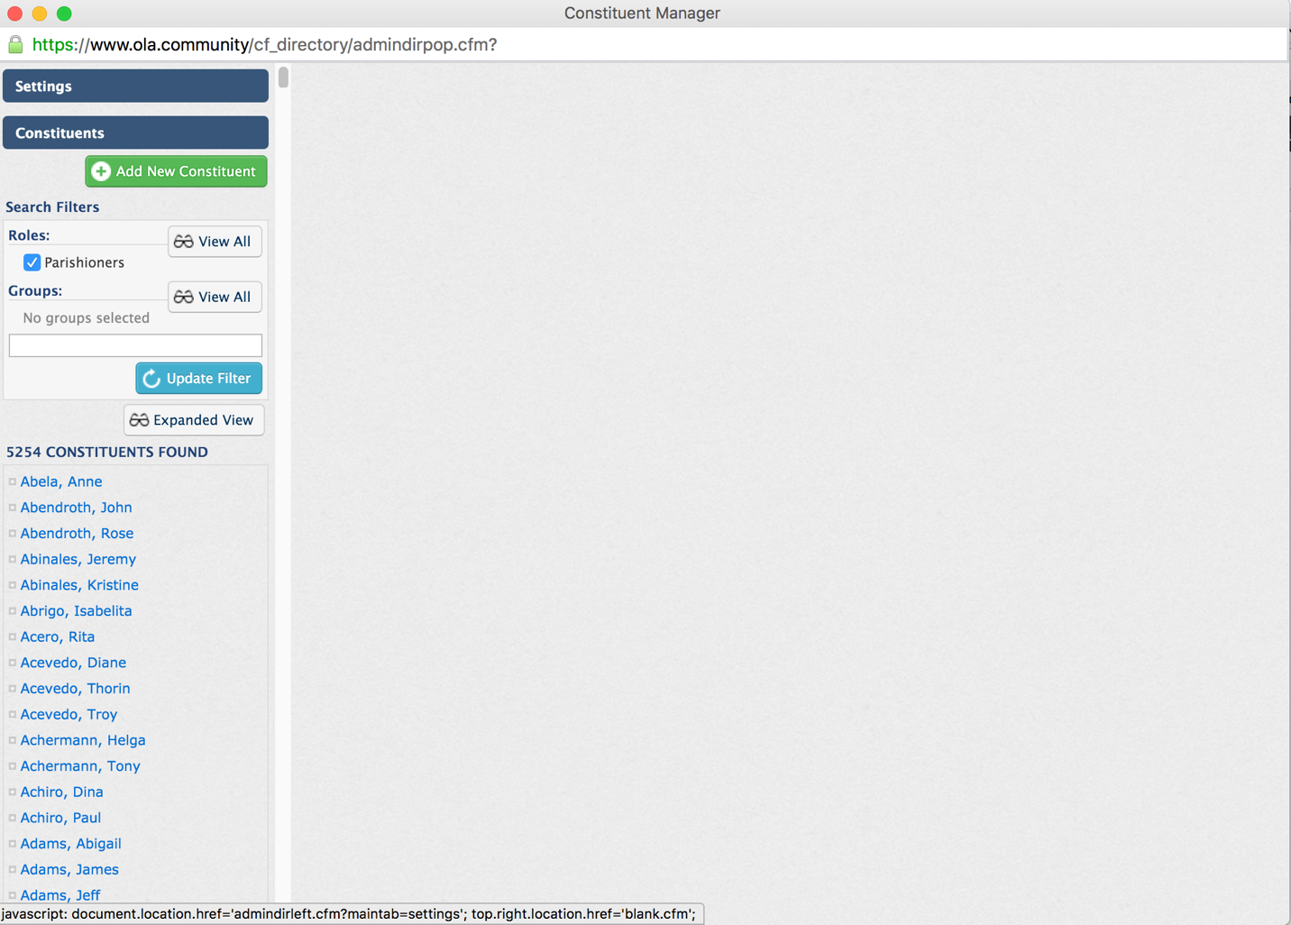

## Step 4: fill in **name, contact** sections and **household relationships** fields

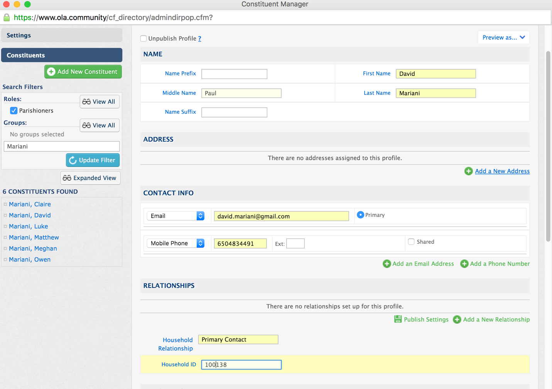

Note: Use “Primary Contact” for the head of household. Otherwise, use “Spouse” or “Child”. Also, make sure to use **PHONE NUMBER** for the “Household ID” field.

## Step 5: fill in the **parish info** section and click **update profile** button

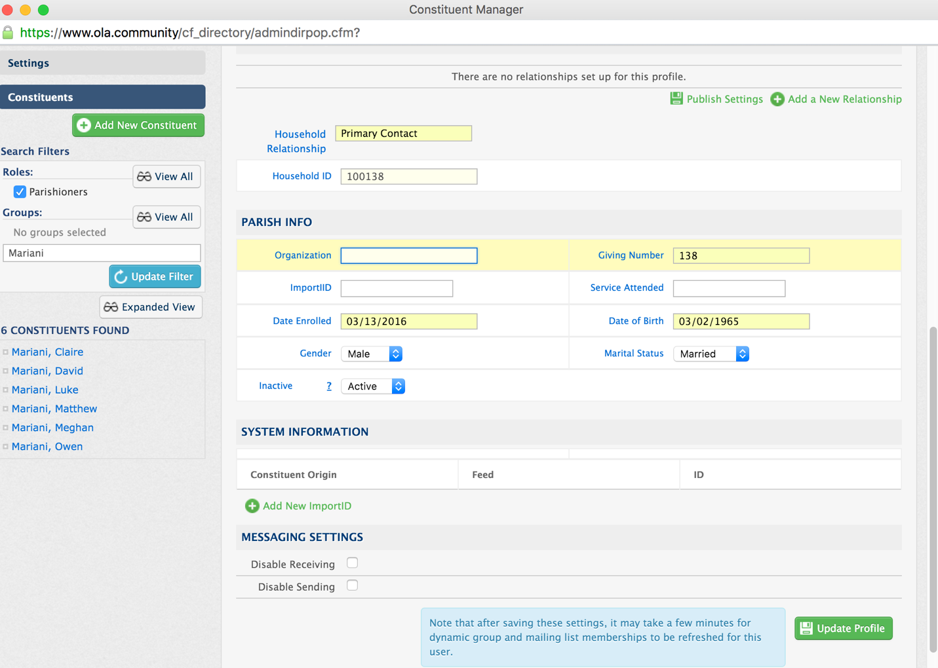

## step 6: Click on the **add a new address** link, fill in the form, click **Add address**

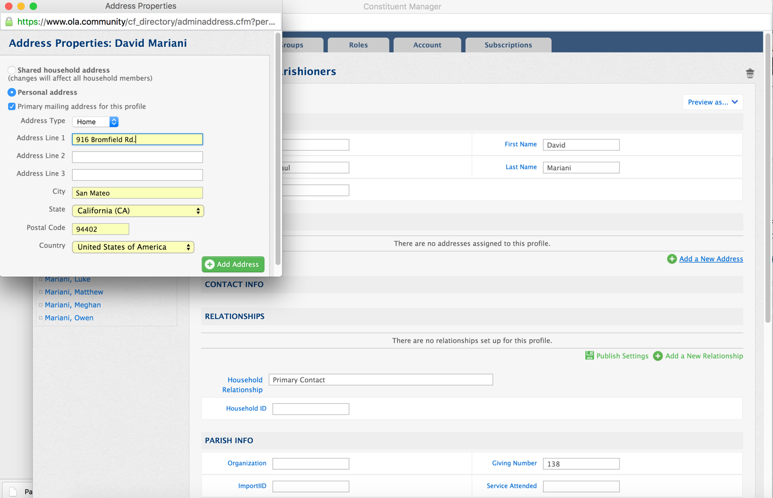

Note: Add each member of the family by repeating Steps 3-6 before proceeding to next step

## step 7: click on the **add a new relationship** link & click **browse** button

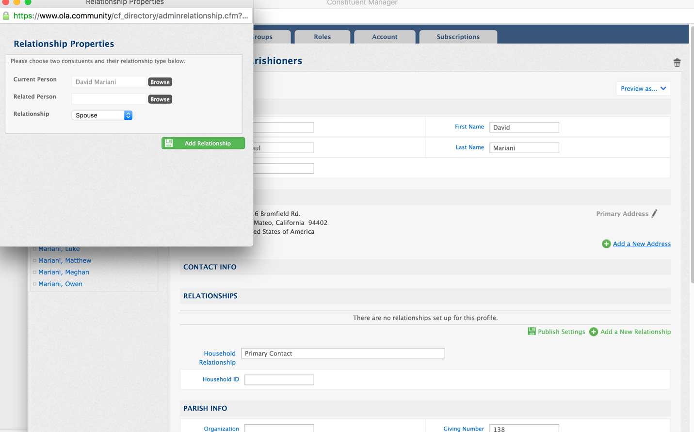

Note: This step is only necessary for the “Primary Contact” profile.

## Step 8: select **parishioners** group and select related profile

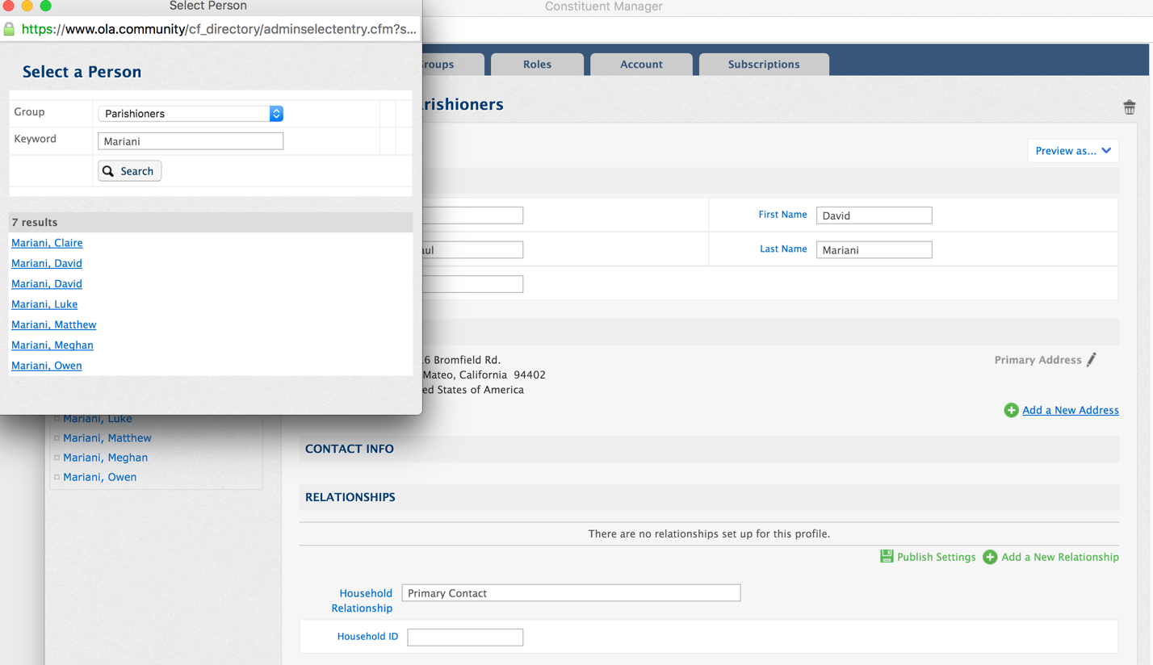

## step 9: click on the **add relationship** button & repeat steps 7-9 if necessary

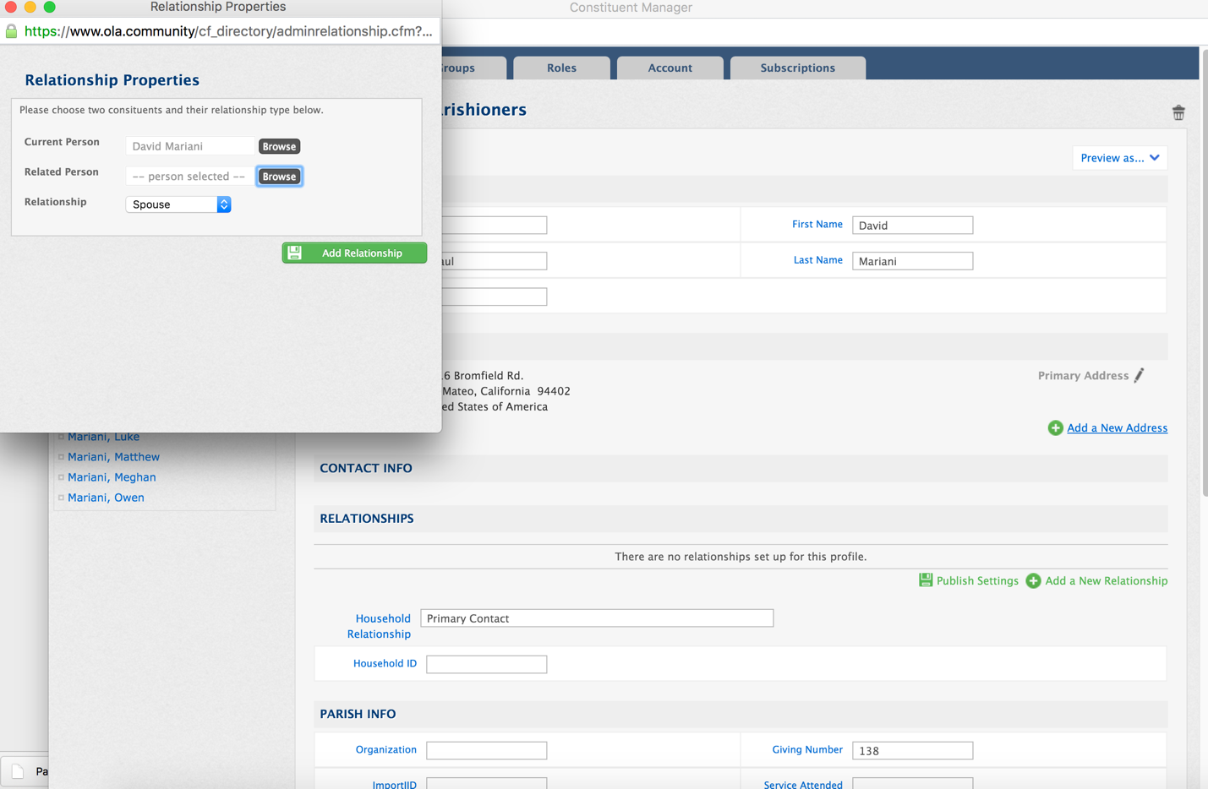

## step 10: click on the **groups** tab, click on the **more groups** & click **save mem..**

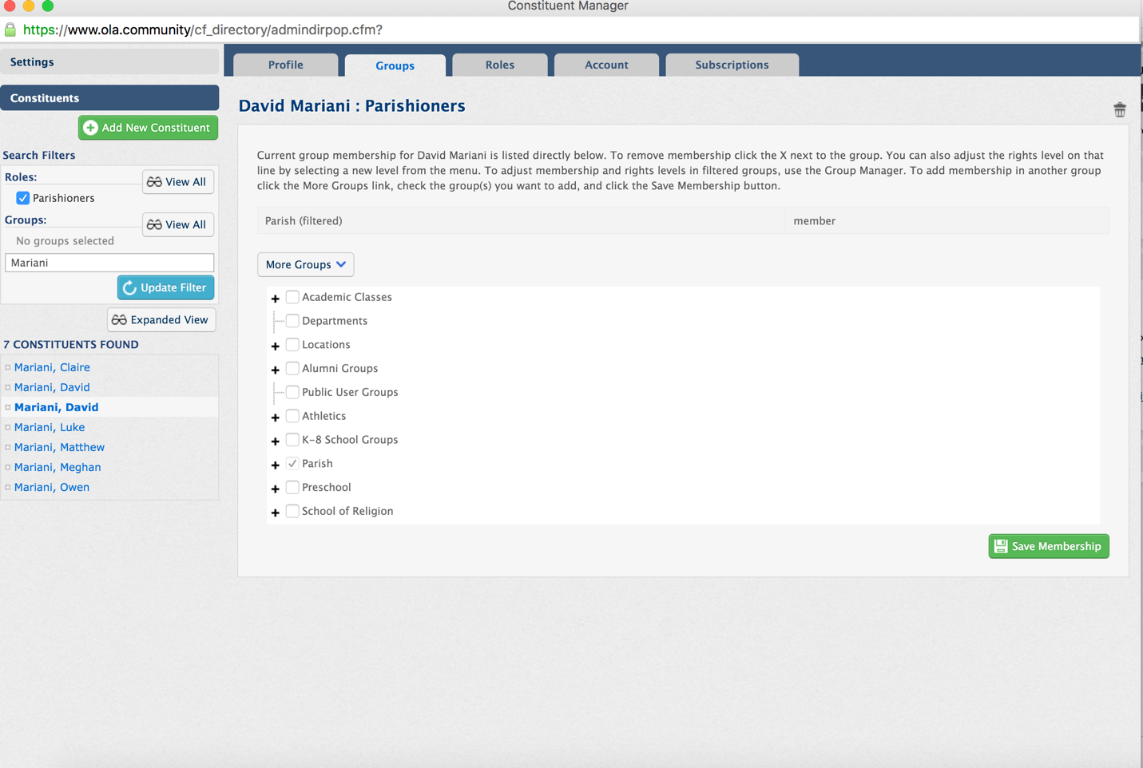

Note: If this is a K-8 school family, make sure to check the appropriate classes for parent or child

## step 11: click on the **roles** tab & check the roles & click the **save roles** button

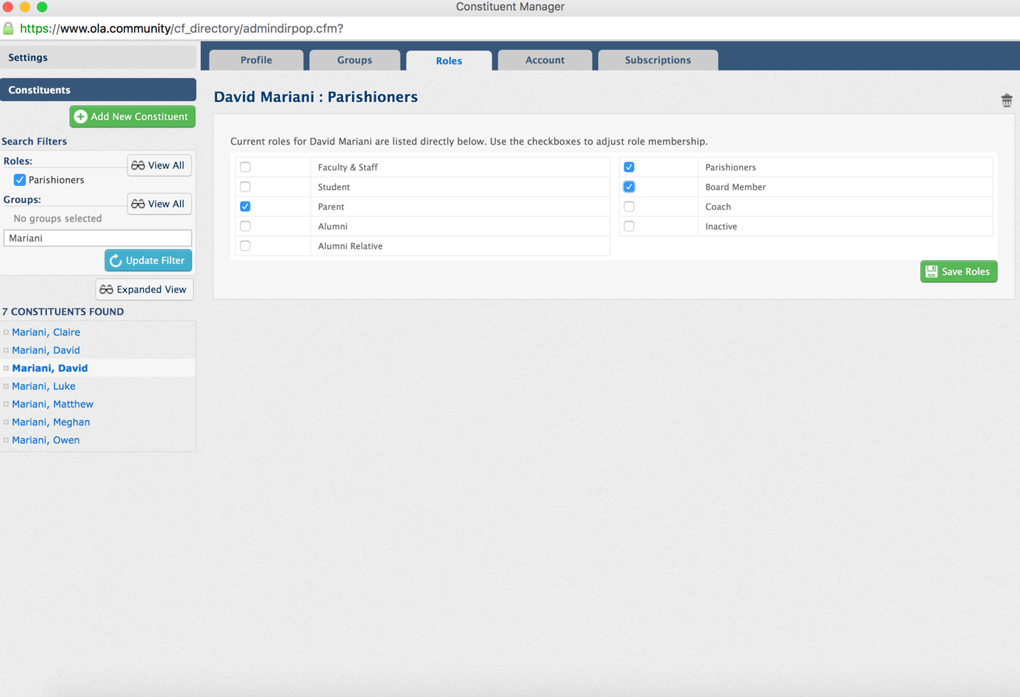

## Step 12: click on the **account** tab and click on the **create portal login** button

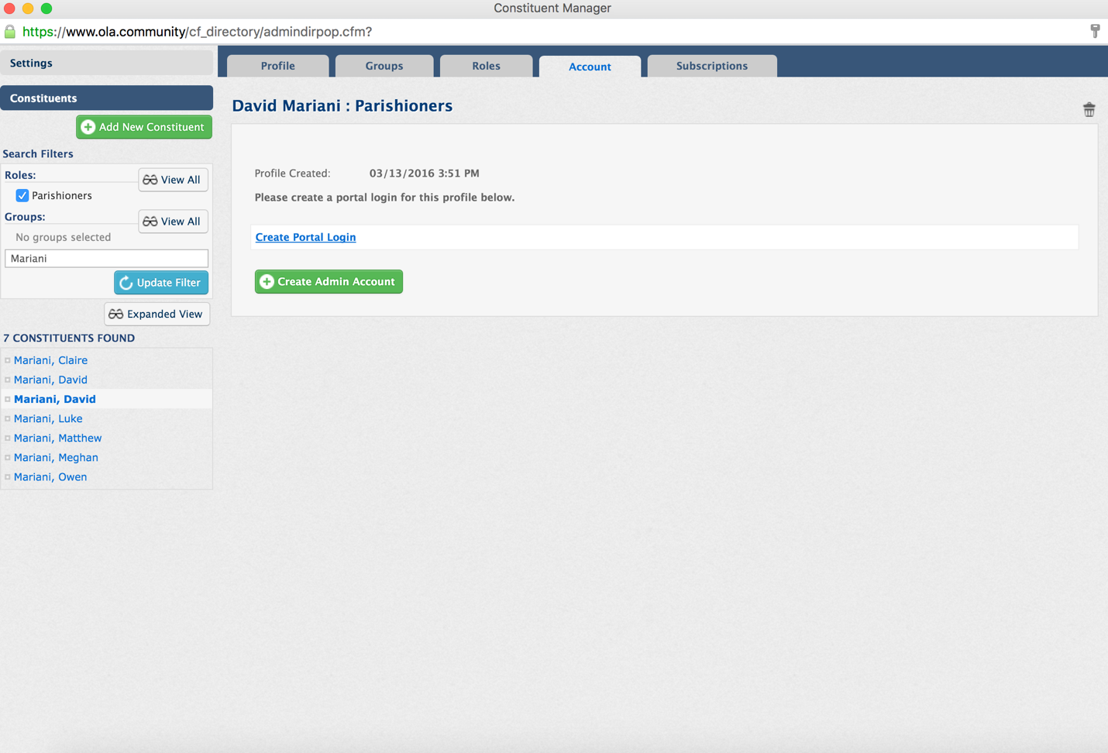

## step 13: fill in **username** and **password** and click the **create login** button

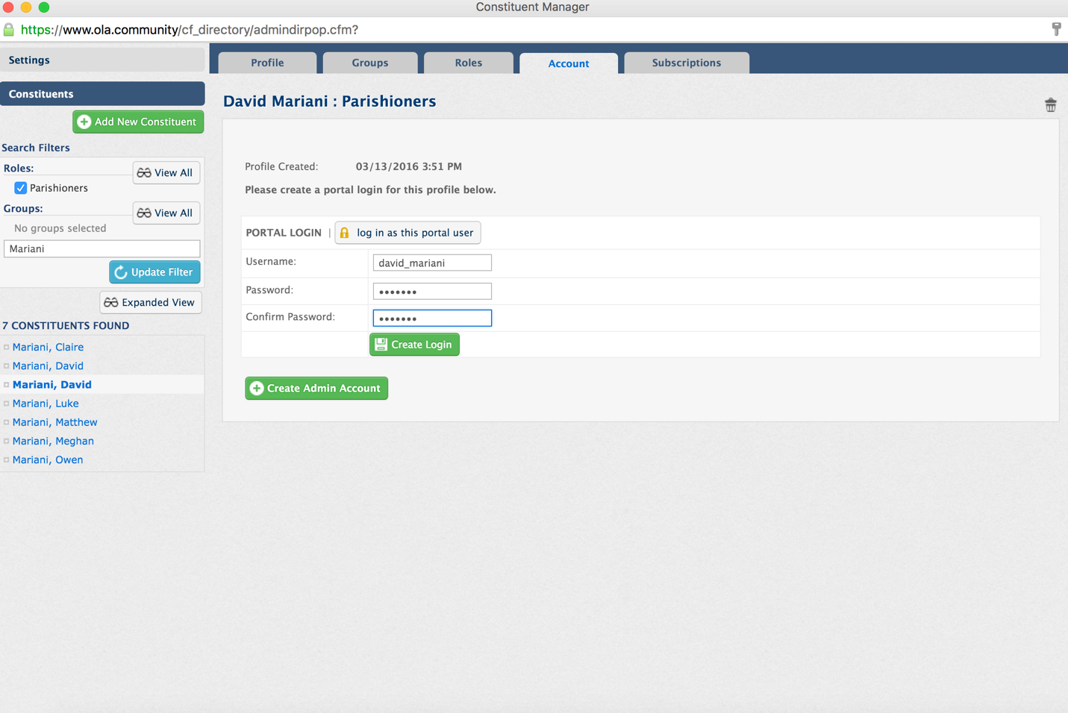

Note: User a **FIRSTNAME_LASTNAME** format for the **Username** field and choose “welcome” for the password